4-29 Main Question (สำหรับแสดงข้อสอบ)

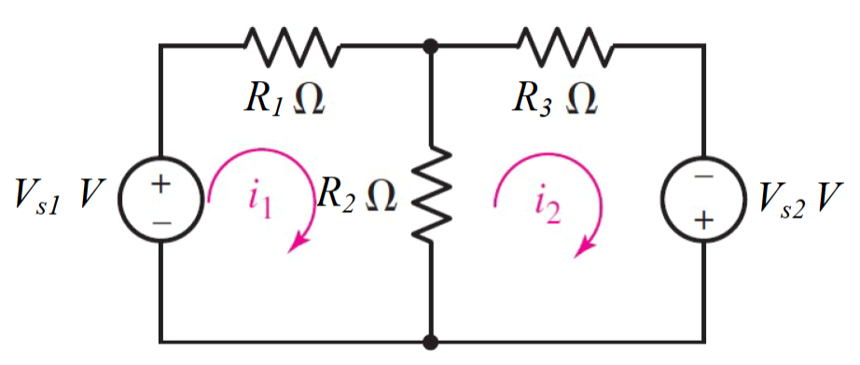

Given *E*1 = 1 V, *E*2 = 2 V, *R*1 = 4 Ω, *R*2 = 1 Ω, *R*3 = 5 Ω.

Find

Variables (สำหรับเขียนโค้ดเพื่อหาคำตอบ)

Random variables

E1 = {1:5}; E2 = {1:5};

R1 = {1:5}; R2 = {1:5}; R3 = {1:5};

Global variables

#E1 = 1; E2 = 2; R1 = 4; R2 = 1; R3 = 5;

Z11 = R1+R2; Z12 = -R2; Z22 = R2+R3;

V1 = E1; V2 = -E2;

D = Z11\*Z22-Z12\*Z12;

D1 = V1\*Z22-V2\*Z12;

D2 = Z11\*V2-Z12\*V1;

I1 = D1/D; I2 = D2/D;

Part (กรอกคำตอบ)

1. *I*1 = I1 = 0.2758 A

2. *I*2 = I2 = 0.3793 A

4-31 Main Question (สำหรับแสดงข้อสอบ)

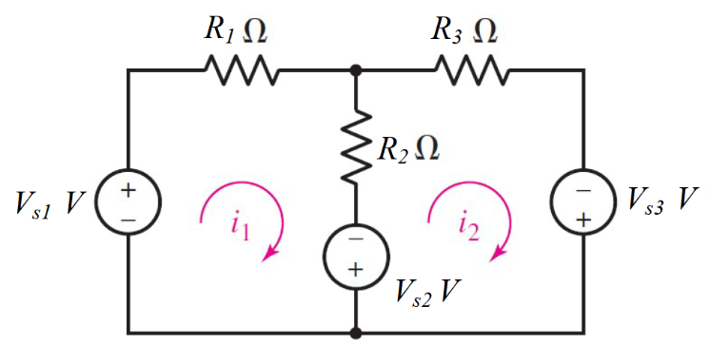

Given *E*1 = 15 V, *E*2 =11 V, *E*3 = 21 V, *R*1 = 9 Ω, *R*2 = 1 Ω, *R*3 = 9 Ω.

Find

Variables (สำหรับเขียนโค้ดเพื่อหาคำตอบ)

Random variables

E1 = {10:15}; E2 = {15:25};

R1 = {5:10}; R2 = {1:5}; R3 = {5:10};

Global variables

#E1 = 15; E2 = 21; R1 = 9; R2 = 1; R3 = 9;

Z11 = R1+R2; Z12 = -R2; Z22 = R2+R3;

V1 = E1+E2; V2 = E3-E2;

D = Z11\*Z22-Z12\*Z12;

D1 = V1\*Z22-V2\*Z12;

D2 = Z11\*V2-Z12\*V1;

I1 = D1/D; I2 = D2/D;

Part (กรอกคำตอบ)

1. *I*1 = I1 = 2.727 A

2. *I*2 = I2 = 1.272 A

4-32 Main Question (สำหรับแสดงข้อสอบ)

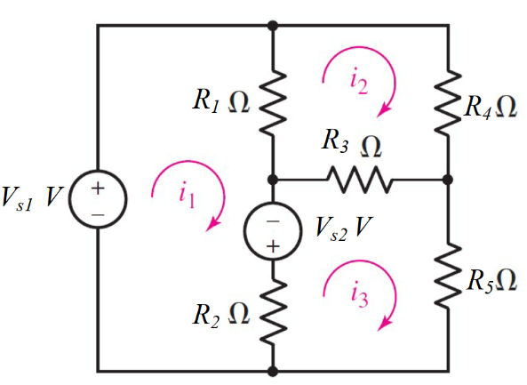

Given *E*1 = 2 V, *E*2 = 3 V, *R*1 = 1 Ω, *R*2 = 5 Ω, *R*3 = 9 Ω, *R*4 = 6 Ω, *R*5 = 7 Ω.

Find

Variables (สำหรับเขียนโค้ดเพื่อหาคำตอบ)

Random variables

E1 = {1:5}; E2 = {1:5};

R1 = {1:5}; R2 = {1:5}; R3 = {5:10}; R4 = {5:10}; R5 = {5:10};

Global variables

#E1 = 2; E2 = 3;

R1 = 1; R2 = 5; R3 = 9; R4 = 6; R5 =7;

Z11 = R1+R2; Z12 = -R1; Z13 = -R2;

Z21 = Z12; Z22 = R1+R3+R4; Z23 = -R3;

Z31 = Z13; Z32 = Z23; Z33 = R2+R3+R5;

V1 = E1+E2; V2 = 0; V3 = -E2;

D = Z11\*Z22\*Z33+Z12\*Z23\*Z31+Z13\*Z21\*Z32-Z31\*Z22\*Z13-Z32\*Z23\*Z11-Z33\*Z21\*Z12;

D1 = V1\*Z22\*Z33+Z12\*Z23\*V3+Z13\*V2\*Z32-V3\*Z22\*Z13-Z32\*Z23\*V1-Z33\*V2\*Z12;

D2 = Z11\*V2\*Z33+V1\*Z23\*Z31+Z13\*Z21\*V3-Z31\*V2\*Z13-V3\*Z23\*Z11-Z33\*Z21\*V1;

D3 = Z11\*Z22\*V3+Z12\*V2\*Z31+V1\*Z21\*Z32-Z31\*Z22\*V1-Z32\*V2\*Z11-V3\*Z21\*Z12;

I1 = D1/D; I2 = D2/D; I3 = D3/D;

Part (กรอกคำตอบ)

1. *I*1 = I1 = 0.989 A

2. *I*2 = I2 = 0.1501 A

2. *I*3 = I3 = 0.1570 A

4-36 Main Question (สำหรับแสดงข้อสอบ)

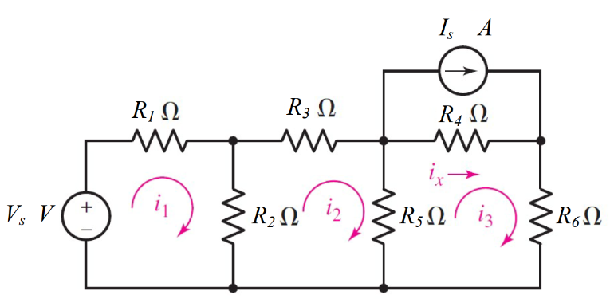

Given *E*s = 3 V, *I*s = 10 A, *R*1 = 8 Ω, *R*2 = 4 Ω, *R*3 = 12 Ω, *R*4 = 20 Ω, *R*5 = 8 Ω., *R*6 = 5 Ω.

Find

Variables (สำหรับเขียนโค้ดเพื่อหาคำตอบ)

Random variables

E1 = {1:5}; Is = {5:10};

R1 = {5:10}; R2 = {1:5}; R3 = {10:15}; R4 = {15:20}; R5 = {5:10}; R6 = {5:10};

Global variables

#E1 = 3; Is = 10;

#R1 = 8; R2 = 4; R3 = 12; R4 = 20; R5 =8; R6 =5;

Z11 = R1+R2; Z12 = -R2; Z13 = 0;

Z21 = Z12; Z22 = R2+R3+R5; Z23 = -R5;

Z31 = Z13; Z32 = Z23; Z33 = R4+R5+R6;

V1 = E1; V2 = 0; V3 = Is\*R4;

D = Z11\*Z22\*Z33+Z12\*Z23\*Z31+Z13\*Z21\*Z32-Z31\*Z22\*Z13-Z32\*Z23\*Z11-Z33\*Z21\*Z12;

D1 = V1\*Z22\*Z33+Z12\*Z23\*V3+Z13\*V2\*Z32-V3\*Z22\*Z13-Z32\*Z23\*V1-Z33\*V2\*Z12;

D2 = Z11\*V2\*Z33+V1\*Z23\*Z31+Z13\*Z21\*V3-Z31\*V2\*Z13-V3\*Z23\*Z11-Z33\*Z21\*V1;

D3 = Z11\*Z22\*V3+Z12\*V2\*Z31+V1\*Z21\*Z32-Z31\*Z22\*V1-Z32\*V2\*Z11-V3\*Z21\*Z12;

I1 = D1/D; I2 = D2/D; I3 = D3/D;

Part (กรอกคำตอบ)

1. *I*1 = I1 = 1.0458 A
2. *I*2 = I2 = 2.3874 A
3. *I*3 = I3 = 6.6394 A

4.38 Main Question (สำหรับแสดงข้อสอบ)

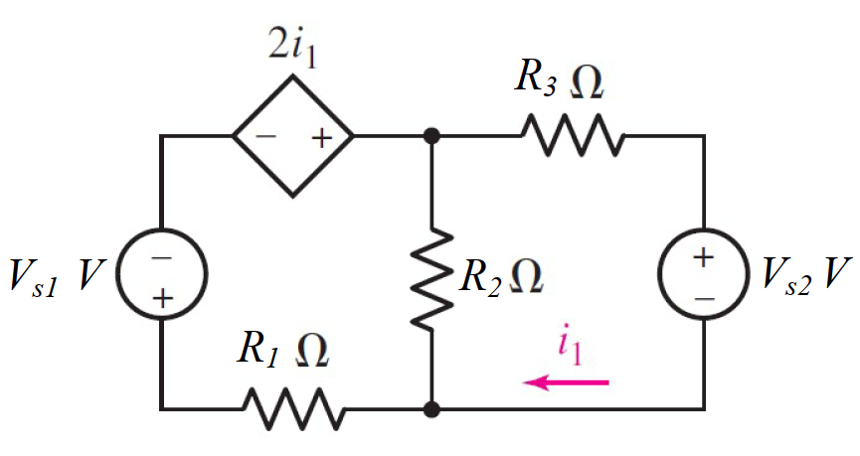

Given *E*1 = 15 V, *E*2 =11 V, *E*3 = 21 V, *R*1 = 4 Ω, *R*2 = 3 Ω, *R*3 = 5 Ω.

Find

Variables (สำหรับเขียนโค้ดเพื่อหาคำตอบ)

Random variables

E1 = {15:20}; E2 = {10:15};

R1 = {1:5}; R2 = {1:5}; R3 = {5:10};

Global variables

#E1 = 1; E2 = 2; R1 = 4; R2 = 1; R3 = 5;

Z11 = R1+R2; Z12 = -2-R2; Z21 = -R2 ; Z22 = R2+R3;

V1 = -E1; V2 = -E2;

D = Z11\*Z22-Z12\*Z21;

D1 = V1\*Z22-V2\*Z12;

D2 = Z11\*V2-Z21\*V1;

I1 = D1/D; I2 = D2/D;

Part (กรอกคำตอบ)

1. *I*1 = I1 = -0.902 A

2. *I*2 = I2 = 0.463 A